### Business Process Name: Search Flight and Payment.

Steps:

|  |  |  |  |  |
| --- | --- | --- | --- | --- |
| **Step Name** | **Description** | **Expected Result** | **Screen Name** | **Transaction Name** |
| Step 1 | Invoke the browser and navigate to http://127.0.0.1:1080/WebTours/index.htm | The web tour Homepage should appear | Homepage | 01_Homepage |
| Step 2 | Enter the username and password and click login | Welcome page should appears | Welcome Page | 02_Welcome Page |
|  | Insert Checkpoint to make sure customer profile title appears |  |  |  |
|  | Insert parameter with unique and each iteration, continue in cyclic manner selection |  |  |  |
|  | Correlate the dynamic value such as session id |  |  |  |
| Step 3 | Click on Flights tab | Find Flight screen appears | Find Flight Screen | 03_ClickFlights |
|  | Insert Checkpoint to make sure Find flight screen is appeared |  |  |  |
| Step 4 | Choose the options for departure city, arrival city, Departure date and Return date | Main Screen should appears | Main Screen | 04_Continue_Mainscreen |
|  | Departure and Return date should be parameterized with date type. | See the date type in parameter | Use the parameter for Departure and Arrival |  |
| Step 5 | Click Continue | Flight list should be displayed |  | 05_ClickFindcontinuebutton |
| Step 6 | Select any flights and click continue | Payment screen should be displayed | Make sure you correlate the outbound flight number (Refer the snapshot) based on the departure and arrival city. Whenever you change the departure and arrival city, you get new flight details.( Hint :  Parameters: Ordinal, | 06_FindFlight_Continue |
| Step 6 | Click Signoff | Home page should appears |  |  |

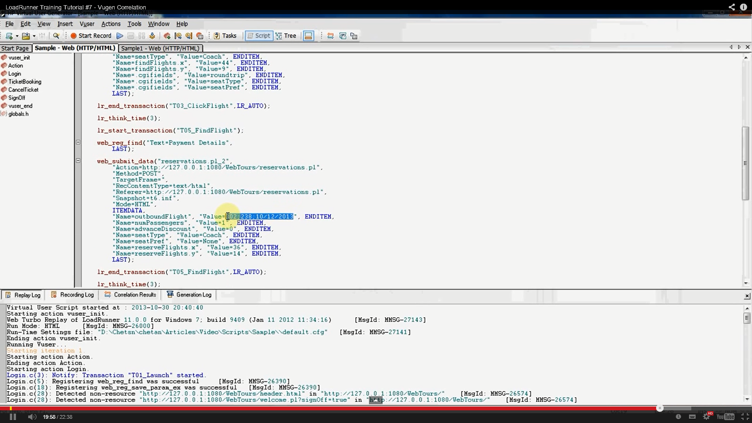

**Correlation point, sample snapshot**

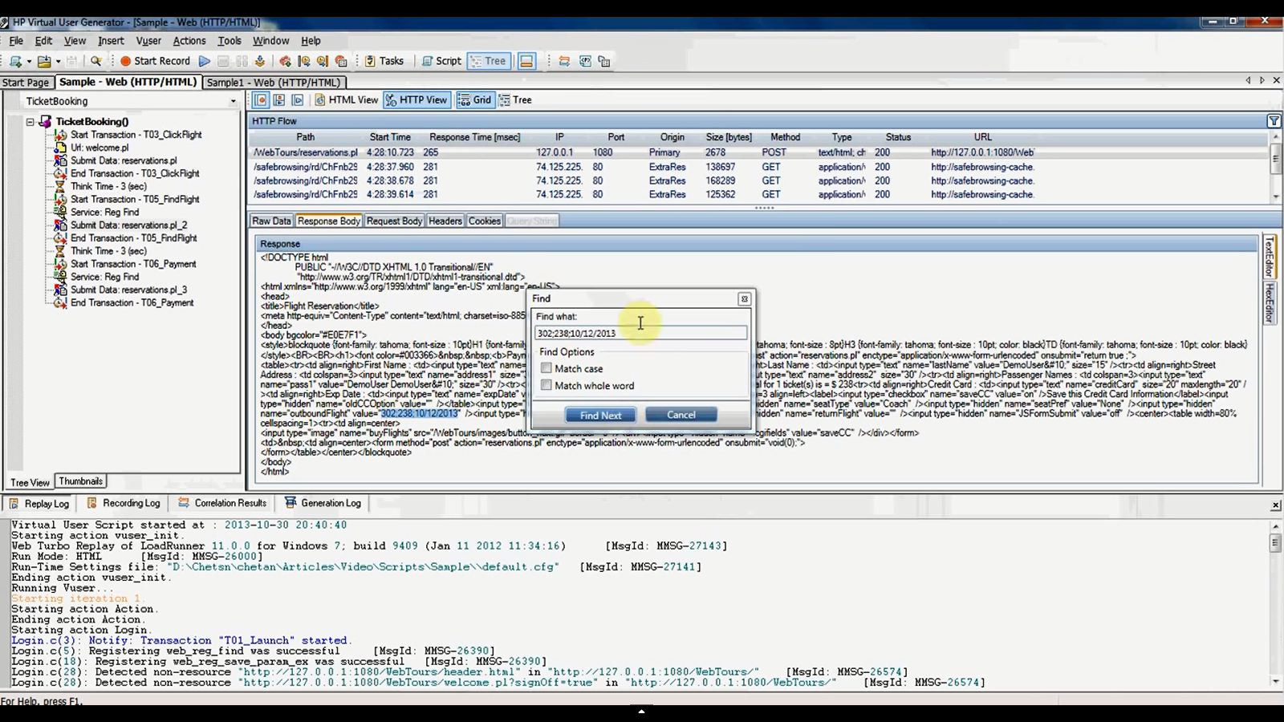

* **Use the following functions in any of the above steps,**

**Lr_get_transaction duration**

**Lr_output_message**

**Lr_eval_string**